Team Exile Rules, Protocols, and Regulations
Version 1.1
Compiled by: Steven M. Burl



Date Created: Friday, January 30, 2009
Last Update: Monday, June 8, 2009
Created for Years: 2009-2010

Team Exile Rules, Protocols, and Regulations
By Steven Burl
With Contributions
By Eric Burl

CEO – Steven Burl
CFO – Eric Burl
VP – DJ Madronio

Team Exile
Base Location – Monterey, Ca
http://www.myspace.com/teamxileit
http://www.exilecrew.org
ceo@exilecrew.org
cfo@exilecrew.org
vp@exilecrew.org
831-235-1250

Index
Index 3
The Purpose of this Document 5
A Semi-Brief History of Team Exile 6
Our Mission and Goals 9
Our Mission 9
Our Goal 9
Team Exile “Trademarks” 10
Divisions and States 12
Divisional Authority 13
Cali Division 13
West Coast Division 13
South Division 13
Northeastern Division 13
Midwest Division 13
Ranking System 14
Hierarchy of Ranking 15
Ranking and Power Rules 16
Ranking Rules 16
Power Distribution 16
Absences 16
Duties and Minimum Requirements 17
Carbon Kevlar Executive Branch 17
Carbon Kevlar 17
Pro Carbon 18
Driver Ranking 21
Technician Ranking 21
Model Ranking 22
Reports 23
Quarterly Dates: 23
Compilation Dates: 23
Pro Carbon 23
Carbon Kevlar 23
Carbon Kevlar Executive Branch 23
Rules and Regulations 24
Code of Exile Drivers 25
Article 1: Minimum Requirements 25
Article 2: Behavior 25
Article 3: Attire 26
Article 4: Attendance 26
Article 5: Required Items 26
Code of Exile Technicians 27
Article 1: Minimum Requirements 27
Article 2: Behavior 27
Article 3: Attire 28
Article 4: Attendance 28
Article 5: Required Items 28
Code of Exile Models 29
Article 1: Minimum Requirements 29
Article 2: Behavior 29
Article 3: Attire 29
Article 4: Attendance 29
Article 5: Required Items 30
Code of Exile Vehicles 31
Article 1: Minimum Requirements 31
Article 2: Upkeep 31
Article 3: Banners and Decals 31
Event Procedures and Purposes 32
Team Meetings 33
Monthlies 33
Pre-Race Briefings 33
Post-Race Debriefings 33
Emergency Meetings 34
Protocols 35
Members 36
Member Recruiting 36
Sample Questions for Interview 36
Promoting 36
Sponsors 38
Rules and Staging 38
Sponsor Recruiting 39
Interviewing 39
Forms 40
Prospect Member Form Example 41
Prospect Member Form Explanation 42
Prospect Sponsor Form Example 43
Prospect Sponsor Form Explanation 44

The Purpose of this Document

Why was this document made?
The purpose of this document is to help you to become familiar with this team and how it operates, along with helping the team to run smoothly. This is a document of Rules, Regulations, and Protocols which will help members of Team Exile in the event that a problem occurs or a member needs to perform a task within the team and needs the proper procedure. This document was intended to convey our policies and rules that keep Team Exile moving forward.

A Semi-Brief History of Team Exile

This is a Semi-Brief History of Team Exile and a recording of an incident that turned Exile around. The purpose of this is to maybe help keep us from making the same mistakes and to learn from other people’s, too. This section of the document should be updated annually.

"The Empire of Exile started here... in this garage... full of shit..."
- Steven Burl (CEO, Co-Founder)

When Team Exile was first formed, it wasn't named Team Exile, it was first known as The AZN Angelz Crew back in mid 2000 in Salinas, CA. The original members were brothers Eric and Steven Burl (Filipino), and Joshua Christian (Korean). The name was picked because all of the members were of Asian decent and they went by the quote, "Never Drive Faster than Your Angels Can Fly." After almost a year of running under the AAC name, they met up with Kevin Ersoy of Marina, CA. He was a friend of Joshua’s and wanted to join up. As most people that are noobs to the scene, they didn’t have the slightest idea of what they were doing. All of them were pretty handy with tools, but the etiquette and experience wasn’t there. Although all of them were into the scene for a decent amount of time before they created the team, most of them didn’t have cars, but they served as mechanics and all the parts that were bought were installed by them in their garages, which is something they still do today.
After a while of debating, they came under the name of Team Si-R. Si-R was an acronym for "Street Import Racing" and was also the trim of one of the most powerful Honda Civic models ever produced. After a while of flying under the Team Si-R flag, Kevin moved away to pursue college, Joshua Christian went to expand Team Si-R, and also a few new members including DJ Madronio, Frank DeAgustineo, and James Tingco hopped on board with Steven and Eric. At this point they were known as Team Dragon. They were a more advanced team, with everyone owning and working on a car. Mostly Hondas, they took to the streets. This is when the “GOT RICE?” sticker was born. Although not a rock solid part of their crew’s identity, the “GOT RICE?” could be found on most of their cars.
Around this time, a good friend named Brenden Tsukimura had passed away, being a victim of a botched robbery attempt. Because of this, The K-Spec Dragon was established. The K-Spec Dragon brought together the friends of Brenden into one racing crew. But as time passed, friends grew apart and The K-Spec Dragon was disbanded.
Now, Team Dragon would be known as The Got Rice Crew, or simply known as The GRC. The GRC members were all of Asian decent again and known for having a "GOT RICE?" decal on their rear windows. The GRC flourished and expanded. It was when non-Asian members would join that they would decide to do another name change.
In mid 2006 The GRC would hold a team meeting to discuss a new name. The members were Steven Burl, Eric Burl, DJ Madronio, Tiffanie Hutchison, Joe Bresciani, Robin Patterson, and Bill Kauffman. That night they decided on the name Team Exodus. It was a majority vote but Eric thought that the name was too biblical.
After a night of brainstorming (and reading through a dictionary), Steven came up with Team Exile. It had a dark and methodical connotation. The meaning struck a certain string with him: One who is expelled either voluntarily or by force of circumstance from a social body or native land. And that's what they were, they didn't fit in the mold of All Honda Teams or All Subie Teams or All Drag Teams or All Drift Teams. They consisted of many types of cars, from Hondas to Jeeps; from drifters to drag racers. And many types of people: Rednecks, Asians, Jocks, and Nerds. This was the appeal of the crew, they were different.
In late 2006, Team Exile would come into contact with members of The Banana Crew and Team 100 Octane. Steven Burl was working at NIA Performance at the time and was a sales representative and installation technician when he came across two members of the Banana Crew. First was Francis Nieves. Francis would bring in his Honda CRX and hang out. After a while, Steven and Francis would become very good friends. Next was Lupe Munoz of Team 100 Octane. Lupe would come in every now and again to hang out and to buy parts. At the time, he was working on a Ford Focus. Last, he would meet Jon Domingo of The Banana Crew. After about two weeks of being acquainted with Jon, they decided to form the Team M1L. The Original Founders of Team M1L were Jon Domingo, Steven Burl, Francis Nieves, DJ Madronio, James Tingco, Lupe Munoz, and Brandon Cobbs. This was in late August. Under the watchful eye of Jon, Steven, and Francis, and the cooperation of the other founders, Team M1L would be strong and together where a line between Team M1L and the M1L Family was clear. On one night, Team M1L had 6 cars out at the Northridge Mall Movie Theatres: Lupe, Jesus, Steven, Jon, Paul, and DJ were lined up in the parking lot. It was then that the D6 (Deadly 6) was created. At the time, no one on the team could remember who the original people were, but it was okay. They went through the remainder of the year like that.
On December 24, Christmas Eve of 2006, Jonathan Domingo passed away in a car accident, forever leaving Team M1L crippled. At the funeral, the D6 had special shirts that had the picture that they took the night D6 was made, except Jesus wasn’t there because he had left M1L about a week earlier to make his own team and even though he knew the funeral was that day, he felt that getting jackets made for his new team was more important. Paul also wasn’t there because he was out of state visiting his brother. About 2-3 weeks after Jon passed away; Steven was going through some old M1L memories from when they first started out. He found the original paper that they had used to scribble out the Team M1L decals the second night they met up and tried to remember where he was when everything was happening and realized they had it all wrong. The members of the D6 weren’t the original founders. In fact only a couple of them were actually right, the two members on the D6 that were no longer on the team weren’t the original members, as he recalled where everyone was that night at Weiner Schnitzel, he realized it was Jon Domingo, Steven Burl, Francis Nieves, DJ Madronio, James Tingco, Lupe Munoz, and Brandon Cobbs that started M1L. They were sitting on a bench with Steven on the right seat of the bench, Jon standing up in front of the bench, Francis sitting on the left side, DJ behind Francis and Lupe behind DJ, Brandon behind Jon, James behind Steven, and Cora in Jon’s car watching her son Caden. That was the day the OD7 (Original Deadly 7) was born to take the place of the D6. Three weeks after Jon passed away, the original founders were realized.
M1L fell into a flurry of power struggles, and where the line between the Team and the Family no longer existed and a new line was drawn: people who wanted to keep the team and the family separate and people who said that they were one in the same. In the end, Team M1L was in shambles and unprofessional with over 40 members and less than 18 cars. Where people who didn’t even own a car, have a license, or even know how to drive had say into what happened on a race team.
The final blow came one Saturday night after a heated debate over what should happen to the people who didn’t have any business being on the Team. Dustin Delameter, who had just recently joined Team M1L handed a notebook to Steven after he parked. Dustin told Steven he had a notebook that everyone said was Jon’s handwriting. Steven read through it and realized just how far they would go. As he read it carefully, it stated that it was Jon’s and that it was the rules for the OD7 and that any member from the OD7 can be booted off by a majority vote from the team. Steven told Dustin to come with him, and he approached about 16 of the M1L “Members” which included Cora Partible (Jon’s Fiancée’), Lupe, Marcie, and Margie and most everyone else that needed a ride to the races. Steven showed the notebook and ordered, “Who said that Jon wrote this?” Everyone replied with a, “Jon wrote it, it’s in his notebook.”
He looked at Lupe.
“Who told you Jon wrote this?” He ordered again.
From Lupe, he got a run-around that ultimately ended at Cora. Cora repeated, “Its Jon’s handwriting.” He told everyone to meet him behind the Weiner Schnitzel where it all started. When everyone got there, he gathered everyone that claimed it was Jon’s in a circle and asked one more time. Everyone gave the same answer again, its Jon’s and therefore it was M1L law and he needed to be kicked off.
Steven threw the notebook down and said that it was a bunch of shit. That no one in the circle was more M1L than he was. That if they knew anything about the team, they would know that the OD7 was made way after Jon had died and in fact it was Steven who figured out who the original founders were and that it was he who had coined the term OD7. And that whoever was the one who was trying to pass it off as Jon’s were the sickest people. He looked at Lupe and told him he should be ashamed of himself, that Jon was a friend, a brother, not some leverage to get what they wanted. Lupe yelled that he loved Jon and walked to a rental truck and punched it. Steven told him, if anyone loved Jon as much as they said they did, no one would have done that bullshit. After that, it was time to call it quits.
Team M1L disbanded for the most part. Some claim that the M1L Family still exists, but the 2 remaining original Team M1L members have disband it. Some members joined other teams, others went solo. For Steven Burl, Eric Burl, Dustin Delameter, Sam Madruga, and Tim Clark, it was a wake up call to re-open Exile.
In Mid 2007, Team Exile was reborn under the same guidelines as before. It expanded from the 831 (Monterey Bay, CA) to the 510 (Hayward, CA) and then out to the 704 (Mooresville, NC). Team Exile: The Blacklisted Drivers represents the breaking away from the mainstream. It means being unique in an otherwise uniform world... That, and they're all crazy as shit.

Our Mission and Goals

Our Mission
"To become one of the most respected and predominate teams in the United States..."

Our Goal
Some people hate us, some love us, others don't even care... but at the end of the day, if we've helped guide someone to be a better, more productive member of the tuning culture, then we've done our jobs. This team isn't just here to help ourselves; we're here to help other people in getting into the scene and progressing. We're here to establish a defined line between "Ricer" and "Racer" - the difference between "Form and Function" and "Flashy and Crappy". We promote the idea of keeping racing and battles off public streets and in controlled areas where innocent bystanders won't be hurt. We face the fact that illegal street racing will never die. In places where illegal street racing is punishable in the most extreme and sometimes unfair ways, it still ceases to parish, so it's one of our goals to help in the movement of making sure that innocent people aren't hurt when people decide to be stupid, and also, to make it known that people that are responsible and do obey laws aren't harassed because of their passion.

Team Exile “Trademarks”

Team Colors:
Black, Red, Gray, White

Team Exile Banner with “Shitty Japanese” which roughly translates to: We urinate on your team.


Exile with Backwards “E”


Team Banner with Team Members’ silhouettes outlined.


Exile with Silhouette of car and driver


Vehicle Picture in 800x130 while moving

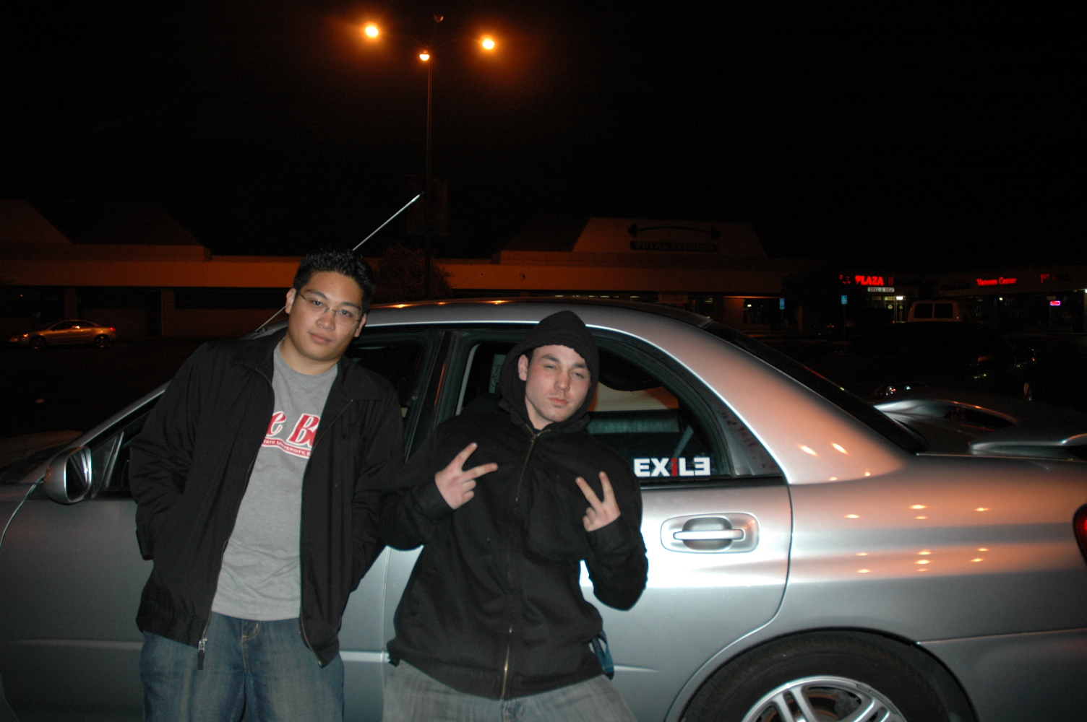
Small Exile Decal on rear windows

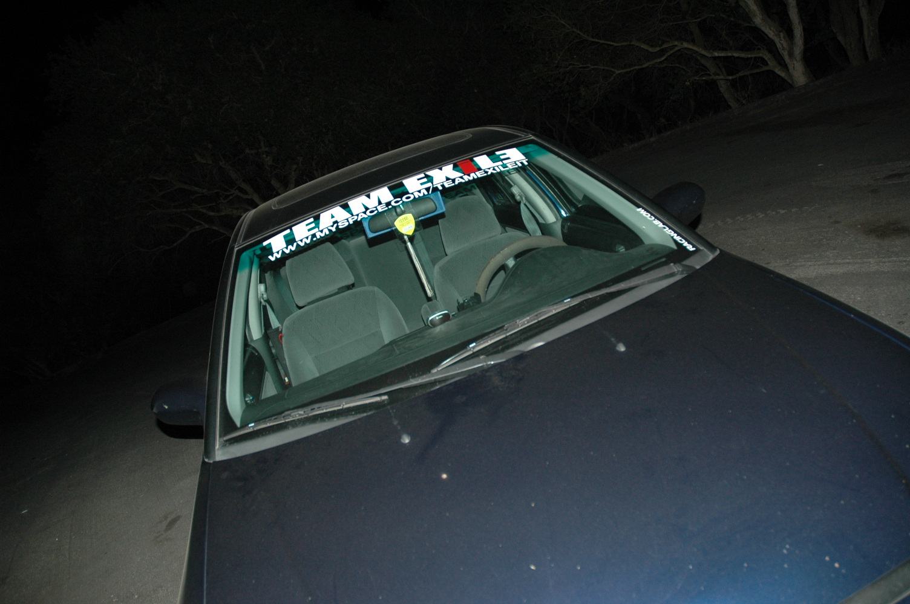
Large 3’ Banner on Windshield

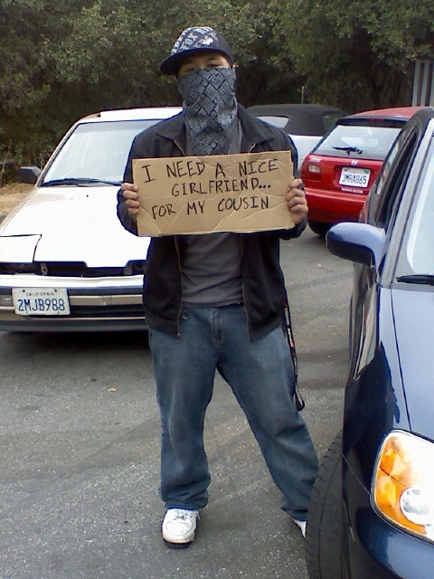
Black/ Exile, Black/Gray, Black/White Bandana
Hazing in public area with cardboard sign

Divisions and States

The Team Exile Divisions have been broken up according to the United States Census Bureau. This will help us in the event that the team does reach a greater size and spreads through the United States. The base of Team Exile will still remain in California. Therefore, California will remain its own Division.
However, Divisions may be broken up into smaller divisional representations which may include, but are not limited to, one (1) State, one (1) county, one (1) city. The breaking of Divisions will be dictated by the number of members or the geographical restrictions. This will be decided upon by the Executive Branch of Team Exile.

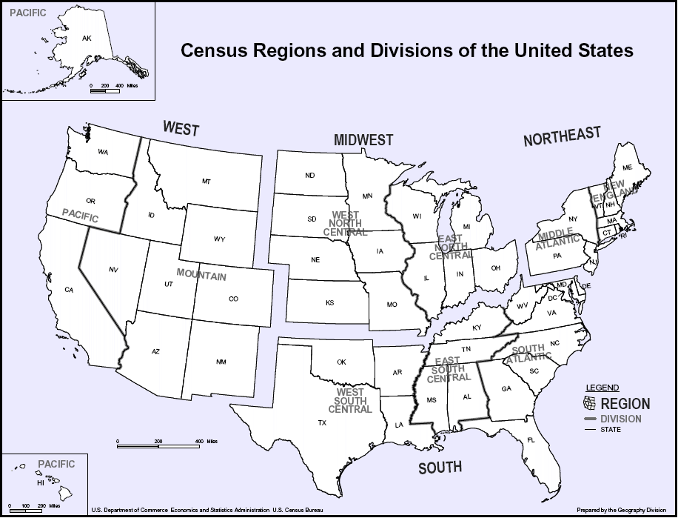

Divisional Authority

Cali Division  California  West Coast Division  Oregon  Washington  Nevada  Idaho  Utah  Arizona  Montana  Wyoming  Colorado  New Mexico  Alaska  Hawaii  South Division  Oklahoma  Texas  Arkansas  Louisiana  Mississippi  Kentucky  Tennessee  Alabama  West Virginia  Virginia  North Carolina  South Carolina  Georgia  Florida  Delaware  Maryland  Washington D.C. | Northeastern Division  Pennsylvania  New York  Maine  Vermont  New Hampshire  Massachusetts  Rhode Island  Connecticut  New Jersey  Midwest Division  Illinois  Indiana  Iowa  Kansas  Michigan  Minnesota  Missouri  Nebraska  North Dakota  Ohio  South Dakota  Wisconsin

Ranking System

Ranking within Team Exile is very important. Without our form of ranking, the team would not have risen as quickly as it did. This is why it is important to observe and follow the teams ranking system. The Team is separated into “Branches” which helps keep the team as streamline as possible; having the Pro Carbon handle pieces of a Division, Division Carbon Kevlar handle a Division, and the Carbon Kevlar Executive Branch hand the team as a whole (all the divisions put together). The Divisions are broken up according to the U.S. Census Bureau’s Divisional map, plus the addition of a Cali Division designed to overlook California only. There is no need, as of now, to refine the divisional process because Team Exile is not big enough to split its members that much. As of now, it requires three (3) members to overlook the whole entire team. It also requires ten (10) members to run a division. So it is decided that until circumstances arise so that we will need to refine our technique of division, we will keep to specific cities and counties chosen by each divisional Carbon Kevlar. In a final note, it is decided that a Division must have a minimum of ten (10) members to become/stay a Division with at minimum eight (8) members serving as Pro Carbon and two (2) members serving as Divisional Carbon Kevlar.

Hierarchy of Ranking

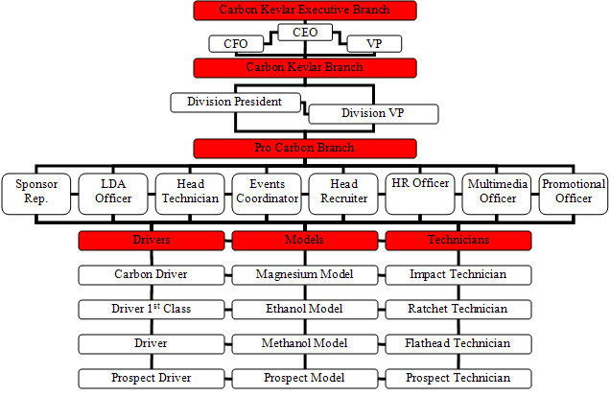

Ranking and Power Rules

Ranking Rules
Any member may hold a Rank from each Tier of Ranking, but only one (1) Rank from each Tier. This also applies to the Driver, Model, and Technician Ranking systems where a Driver can only possess one (1) Driver Ranking, a Model can only possess one (1) Model Ranking, and a Technician can only possess one (1) Technician ranking. The difference is that Driver, Model, and Technician Rankings share the same Tier but not the same Category, so one (1) Member can possess a Driver, Model, and also a Technician Ranking at one (1) time.

Power Distribution
Observe that there will only be one Carbon Kevlar Executive Branch for Team Exile. The Team CEO, CFO, and VP have final say in all decisions with the power percentages being 40%, 30%, and 30% respectively over the entire team. This will only take effect if the CEO, CFO, and VP jointly agree that a team decision has been made that will divert the team in any way shape or form from the team’s missions, goals, purposes, etc. Equal power over all Team Exile Divisions and members is awarded to all Carbon Kevlar Executive Branch Members.
There will be one Carbon Kevlar Branch for each Division with one (1) Division President and one (1) Division VP. The power percentages are 60% and 40% respectively, but equal power over all Pro Carbon Branch Members, Drivers, Technicians, and Models is awarded to their respective Division Presidents and Division VPs.
There will be one (1) member to fill each Pro Carbon Branch Rank for each Division. Each member of the Pro Carbon Branch will have equal power (12.5%) over the Divisional processes below them. In the event that a stalemate of votes is issued at the Divisional Pro Carbon Branch, then the Divisional Carbon Kevlar may vote on the option or give the right to decide on the matter to the Drivers, Technicians, and Models.

Absences
If a member is not present without a proper excuse decided upon by their peers and CO’s, their vote is not counted. Their voting power is distributed equally amongst their peers in the same Tier and/or Category. If a power slant is present like in the case of the CEO, CFO, and VP, then their voting power is distributed accordingly so that a proper power ratio is still present.
In the event that a member is absent for a short period of time with a verifiable and good excuse, an attempt to attain their vote within the deadline given will be acceptable. If a vote is not attained before a decision must be made, their vote does not count.
If a member is not present for a long absence with an accusable reason for that absence, then an “Acting Temporary” will be placed by peers and/or CO’s. If a vote for that Acting Temporary Position is necessary and/or possible, then one will be assigned via voting. If that is not possible, responsibility of placement of the Acting Temporary will be placed on that positions’ CO’s and the decision is ultimately up to the CEO of Team Exile en leau of voting.

Duties and Minimum Requirements

Carbon Kevlar Executive Branch
Chief Executive Officer (CEO)/ President – The team CEO overlooks the team as a whole. The CEO takes the reports provided by the Carbon Kevlar Branch and makes decisions based on such information. The CEO is in charge of any Team Work that is not assigned to another member.
Requirements: A Personal Computer or Laptop
Internet Access on a regular basis
A Team Email Account
Microsoft Office Software
Business background/experience
Leadership background/experience
Organizational Skills
One of the Senior Members of Team Exile
Chief Financial Officer (CFO) – The Team CFO overlooks the team’s finances and financial records. The team CFO handles the team bank account and team expenditures including, but not limited to, parts for team projects, team website, and track and dyno time. The CFO makes sure that all team members have paid for what they need to pay for and that all the funds go where they need to go.
Requirements: A Personal Computer or Laptop
Internet Access on a regular basis
A Team Email Account
Microsoft Office Software
Finance/Accounting Software
Finance/Accounting background
Leadership background/experience
Organizational Skills
One of the Senior Members of Team Exile
Vice President (VP) – The Team VP helps overlook the team as a whole. The team VP acts as the team CEO in the absence of the CEO. The VP also supports the CEO in the CEO’s duties. The VP votes along side the CEO and CFO to make the best decision for the team.
Requirements: A Personal Computer or Laptop
Internet Access on a regular basis
A Team Email Account
Microsoft Office Software
Business background/experience
Leadership background/experience
One of the Senior Members of Team Exile

Carbon Kevlar
Division President – The Division President is in charge of over-viewing a Division of Team Exile. They are in charge and accountable for whatever Division they lead. All Division Presidents will collect their Division Quarterlies and devise a Compilation to be turned into the Executive Branch.
Compilation: Sponsor updates
Logo, Decal, and Apparel distribution and inventory
Vehicle updates
Events attended
New members and Vehicles
Any issues that have arose
Overview of photo shoots and model updates
Overview of hits per website (if possible)
Summary of all Division Quarterlies
Requirements: A Personal Computer or Laptop
Internet Access on a regular basis
A Team Email Account
Microsoft Office Software
Business background/experience
Leadership background/experience
One of the Senior Members of their Team Exile Division
Division Vice President (VP) – The Division VP is in charge of a secondary over-viewing of a Division of Team Exile. They are in charge and accountable for whatever division they co-lead. All Division VP’s will collect their Division Quarterlies and devise a Compilation to be turned into the Executive Branch.
Compilation: Sponsor updates
Logo, Decal, and Apparel distribution and inventory
Vehicle updates
Events attended
New members and Vehicles
Any issues that have arose
Overview of photo shoots and model updates
Summary of all Division Quarterlies
Overview of hits per website (if possible)
Requirements: A Personal Computer or Laptop
Internet Access on a regular basis
A Team Email Account
Microsoft Office Software
Business background/experience
Leadership background/experience
One of the Senior Members of their Team Exile Division

Pro Carbon
Sponsor Representative – The Sponsor Representative has the duty of securing sponsors, creating a good report with them, and keeping in touch with sponsors. The Sponsor Representative is in charge of any paperwork and updating any sponsor requires and is in charge of making sure that all paperwork is done in a timely manner before its deadline.
Quarterly: Sponsor Updates
Requirements: A Personal Computer or Laptop
Internet Access on a regular basis
A Team Email Account
Microsoft Office Software
Spreadsheet experience
Organizational skills
Logos, Decals, and Apparel (LDA) Officer – The LDA Officer is charged with retaining team accessories and distribution of these goods. The officer will make sure that all team members have all of the required items and that these items have been paid for.
Quarterly: Items Distributed
Inventory
Accounting of funds
Requirements: A Personal Computer or Laptop
Internet Access on a regular basis
A Team Email Account
Microsoft Office Software
Spreadsheet Software
Spreadsheet experience
Head Technician – The Head Technician has authority over all Division Technicians. They are in charge of making sure that all Division Technicians are doing their jobs during events. The Head Technician is ultimately in charge of keeping a roster of all campaigning vehicles along with all cars not in campaignable condition.
Quarterly: An account of all active vehicles
An account of all inactive vehicles
Requirements: A Personal Computer or Laptop
Internet Access on a regular basis
A Team Email Account
Microsoft Office Software
Organizational skills
Leadership background/experience
Advanced experience in difficult automotive diagnosis and repair
Events Coordinator – The Event Coordinator is in charge of finding and booking. If the team is a non-participant, the Event Coordinator is in charge of securing tickets and/or passes. The Event Coordinator is responsible for making sure that all members have some sort of event to participate in and is ultimately responsible for relaying information to their Division members and securing spots for members that want to participate. The Event Coordinator is also in charge of the Team Calendar, which must be published and distributed at the first Team Meeting or Emergency Meeting of the year.
Quarterly: Event participation
Member attendance
Team Calendar
Requirements: A Personal Computer or Laptop
Internet Access on a regular basis
A Team Email Account
Microsoft Office Software
A personal phone
Calendar software
Organizational skills
Head Recruiter – The Head Recruiter handles all prospective members. The Head Recruiter evaluates prospective members then reports if the prospective member should be allowed to officially join Team Exile.
Quarterly: Information on new members
Requirements: A Personal Computer or Laptop
Internet Access on a regular basis
A Team Email Account
Microsoft Office Software
Human Resources (HR) Officer – The Human Resources Officer is in charge of making sure that the team runs smoothly as a team. If there are any questions that need to be asked by team members, The HR Officer is the person that these members would come to first to get anything sorted out. The HR Officer is in charge of overseeing the team as a family and making sure that all relationships are in top shape and that all personal problems that are affecting the team are handled in one way or the other. The HR Officer is also in charge of delegating orders and/messages from the upper ranks.
Quarterly: Issues within Team Exile
Revisions or adds into rules and regulations
Any recommendations for drops from the team
Requirements: A Personal Computer or Laptop
Internet Access on a regular basis
A Team Email Account
Microsoft Office Software
Psyc/Soci Studies
Multimedia Officer – The Multimedia Officer is in charge of taking photographs and/or video recordings at team events. The officer is then in charge of compiling and editing these pictures and video. The distributions of these are also the responsibility of the Multimedia Officer.
Quarterly: Issues
Finances
Vehicles Photographed and videoed
Current Model Roster
Model Exposure
Requirements: A Personal Computer or Laptop
Internet Access on a regular basis
A Team Email Account
Microsoft Office Software
Microsoft Office experience
A Professional Grade Digital Camera
A Digital Video Camera
Photography background/experience
Photo Editing Software
Photo Editing experience
Video Editing Software
Video editing experience
Promotional Officer – The Promotional Officer is in charge of keeping a good rapport with fans and the public. They are in charge of updating all of the team’s web pages and keeping the public informed of our activity along with providing visual representation of us on these pages. They are obligated to work towards promoting our team in any way possible, such as providing fan based items such as shirts, decals, DVDs and other promotional merchandise that may go towards providing income for Team Exile use. The Promotional Officer is in charge of the:
Team Website
Team Myspace.com Profile
Team Myspace.com Group Page
Quarterly: Traffic Report
Feedback
Fan base
Requirements: A Personal Computer or Laptop
Internet Access on a regular basis
A Team Email Account
Microsoft Office Software
Microsoft Office experience
Website building software
Website Management experience

Driver Ranking
Carbon Driver – Carbon Drivers are drivers that are entered in a series and participate in over 60% of the series. A placing is not required.
Requirements: Must be on roster
Must be an Active Driver
Must be entered in a series
Driver 1st Class – Driver 1st Class Members are drivers that participate in at least one (1) event. They are not required to have a series license.
Requirements: Must be on roster
Must be an Active Driver
Must participate in at least one (1) race event
Driver – Drivers are the base ranking for active members. Drivers are Active Drivers that are not entered into any racing series and have not attended one as a participant.
Requirements: Must be on roster
Must be an Active Driver
Prospect Driver – Prospect Drivers on not an Active Member. Prospect Drivers are on their probationary period and have no voting rights.
Requirements: Must be on roster

Technician Ranking
Impact Technician – Impact Technicians are just below the Head Technician. These Technicians are in charge of the crew of lower technicians during race days. They must have an advanced knowledge of automotive technology.
Requirements: Must be on roster
Must be an Active Technician
Must have experience in difficult automotive diagnosis and repair
Must have experience in difficult automotive performance
Ratchet Technician – A Ratchet Technician is just below the Impact Technician and must know intermediate automotive technology such as replacing suspension bearings and such.
Requirements: Must be on roster
Must be an Active Technician
Must have experience in intermediate automotive diagnosis and repair
Flathead Technician – Flathead Technicians are in Active Status but are the basic technician. Flathead Technicians must be able to identify basic vehicle parts and tools and be able to perform basic maintenance on a vehicle.
Requirements: Must be on roster
Must be an Active Technician
Prospect Technician – Prospect Technicians are technicians that are on roster but are on their probationary period before being voted into Active Status. Prospect Technicians need to be voted on to reach Active Status. Prospect Technicians have no voting right.
Requirements: Must be on roster

Model Ranking
Magnesium Model – Magnesium Models are the spokes-models for Team Exile. Magnesium Models come to events and answer any questions that people may have about the team and/or vehicles and the drivers that drive/own those vehicles. Magnesium Models have the authority to vote.
Requirements: Must be on roster
Must be an Active Model
Must have an in depth knowledge of all cars campaigning and the
owner/driver of those vehicles
Must have an in depth knowledge of Team Exile
Ethanol Model – Ethanol Models are spokes-models for a car that is campaigning on Team Exile. They must know about a driver and vehicle on the team so that they can answer questions on a specific car and/or driver on the team. Ethanol Models have the right to vote.
Requirements: Must be on roster
Must be an Active Model
Must have an in depth knowledge of (1-2) vehicles campaigning
and the owners/drivers.
Must have an in depth knowledge of Team Exile
Methanol Model – Methanol Models are models that accompany Team Exile to events. Methanol Models have the right to vote.
Requirements: Must be on roster
Must be an Active Model
Prospect Model – Prospect Models are models that are on roster but are on their probationary period. Prospect Models need to be voted on to reach active status. They do not have voting right until they reach Active Status.
Requirements: Must be on roster

Reports

Quarterly Dates:
1st of January
1st of April
1st of July
1st of October

Compilation Dates:
1st of June
1st of December

Pro Carbon
Each Pro Carbon Member will produce a Quarterly Report depicting all the information that they are responsible for gathering according to their duties from the past three (3) months. They then submit the information to their Carbon Kevlar branch to be compiled. Three (3) documents will be produced. One (1) copy will be saved for the producer of the document, two (2) will be sent to their Divisional Carbon Kevlar Branch. One (1) copy will be retained, processed, and filed for the Carbon Kevlar Branch to use in summarization and to keep in Archives.

Carbon Kevlar
Compilations will be produced by the Carbon Kevlar Branch depicting any information deemed pertinent to Team Exile. These will be summarized and compiled into one (1) document which will be due in the middle of the year and the end of the year. These will depict a summary of the two (2) Quarterly Reports that came before it. A copy of the two (2) Quarterly Reports that they depict will be attached to the back of the document for Archiving. A copy of the Compilation may be retained for archiving.

Carbon Kevlar Executive Branch
The Compilations from the Carbon Kevlar Branch will be processed by the Carbon Kevlar Executive Branch and decisions will be made based upon the Compilations and/or Quarterlies and their own notes and documentation.

Rules and Regulations

Throughout Team Exile’s history, there have been instances of failure in the upkeep of our image. As shallow as it may seem, without our image we wouldn’t be able to have the things that we have now. Without a good image, our sponsors would drop us. We represent not just Team Exile, but our sponsors also, and no sponsor wants an un-likeable representative. These rules and regulations are not only to upkeep our image, but to ensure:

There are no problems within the team
That Team Exile is a respectable team
That the team progresses under all possible circumstances and will progress together as a whole

Code of Exile Drivers

Article 1: Minimum Requirements
1. Must be 16 years of age.
2. All members must have a Driver’s License or Body License. A license under suspension or has not been renewed is okay as long as the owner does not drive to and from events or going on a Team Exile sponsored outing. I license that has been revoked is up for debate among Pro Carbon. This will ensure that a prospect member knows the rules of the road or of a race series.
3. Have Vehicle. A vehicle in working condition is preferable, but project cars will be voted on based on their potential and/or current merits.
4. Must be attending some sort of schooling and/or retain some sort of employment.
5. Must have some sort of reliable income.
6. Must be able to commit to the team
7. Must have a background and/or experience in dealing with basic automotive mechanics. Knowledge of basic automotive principles is a requirement and a member will be asked to demonstrate their knowledge in the following categories:
Basic Automotive Principles
Basic Maintenance
Basic Aftermarket Maintenance
8. All members must be able to perform basic OEM maintenance on their vehicle, but will not be required to perform such tasks.
9. All members will be required to perform basic maintenance on aftermarket parts on their vehicle on a regular basis. If member does not know how, depending on the skill level required, that member will be either taught how to maintain the part or referred to their CO’s for proper assessment.
10. Know your car and the parts in it – members that do not will be referred to the Council to be dealt with accordingly.

Article 2: Behavior
1. No more passengers to a vehicle at the runs than there are doors.
2. Members must respect the road, other drivers, and pedestrians. Do not cut off other drivers or pedestrians or any unsafe driving that may put other people at risk of injury. Any member caught doing so either by team members or witnesses will be ejected from the team.
3. All members must maintain good driving habits and drive within the limits of their vehicle.
4. No member will engage in any unsafe driving activities, such as talking or texting on your cell phone while driving, which will cause the driver to swerve and/or lose proper line on the road.
5. Any member with less than desirable driving skills that have been witnessed by members of the team and/or reported to CO’s by multiple witnesses will be ejected from the team until driving improves.
6. Members will not be allowed to engage in any activity that will make Team Exile lose credibility and/or respect – especially parking lot tactics – such as burnouts, excessive speed when not required, drifting, excessive revving, etc. (speak softly, but carry a big stick). Members engaged in these activities will be dealt with by the team at meetings.
7. Members must respect all paddock rules and NOT leave children unattended.
8. Shit-talking and trouble-starting will not be tolerated. Any problems associated with this topic will be dealt with by the team at team meetings.
9. No hustling whatsoever. Any member caught hustling will be expelled from the team.
10. No reverse-hustling. Boasting is unsportsmanlike and will dealt with according to the degree of which it entails.
11. No member or guest will be under the influence of alcohol or narcotics at any of the team meets with exception to Crew meets (Not team meets), where alcohol is allowed. Any member or guest that breaks this rule will be ejected from the team and banned from all team meets.
12. Leave all problems at home, this team operates as friends and family, but foremost, a team. Be professional.
13. Members take full responsibility for their guests at all events.

Article 3: Attire
1. At team meets, all members must have presented and visible a minimum of one (1) Team Exile apparel piece.
2. All attire at Team Exile events must be tasteful and G-17 rated style clothing. No profanity or excessively revealing clothing.

Article 4: Attendance
1. Attendance from all members is a must at all required events.
2. Any member with more than four (4) unexcused absences within a year will be dismissed from the team.
3. Any member with more than four (4) consecutive unexcused absences will be dismissed from the team.

Article 5: Required Items
1. Must have a 2-way
2. Must fill required Pending Member Form to full extent and submit to the Council.
3. After probation, all members must pay a $60 membership fee for membership items.
4. All Members must be on the Member Roster and have an Info sheet along with contact information submitted to the Council.
5. All Members must pay a $5.00 due each month to maintain the team. Any member that misses a dues payment will owe that money on the next payment. Advanced payment will be credited to you. Any and all money paid to Team Exile required items and team bills cannot and will not be returned and will be counted as payment for any discount parts and favors associated with the team.

Code of Exile Technicians

Article 1: Minimum Requirements
1. All members must have a Drivers License. A license under suspension is okay as long as the owner does not drive to and from events or going on a Team Exile sponsored outing.
2. Have Vehicle. A vehicle in working condition is preferable, but project cars will be voted on based on their potential and/or current merits.
3. Have Insurance for the vehicle that you are driving. Any vehicle on the road with any Team Exile logo or trademark and/or any logos or trademarks of our affiliates will be suspended from the team until further notice from superiors.
4. Must be attending some sort of schooling and/or retain some sort of employment.
5. Must have some sort of reliable income.
6. Must have a background and/or experience in dealing with technicians. Knowledge of basic automotive principles is a requirement and a member will be asked to demonstrate their knowledge in the following categories:
Basic Automotive Principles
Basic Maintenance
Basic Aftermarket Maintenance
7. All members must be able to perform basic OEM maintenance on their vehicle, but will not be required to perform such tasks.
8. All members will be required to perform basic maintenance on aftermarket parts on their vehicle on a regular basis. If member does not know how, depending on the skill level required, that member will be either taught how to maintain the part or referred to their CO’s for proper assessment.
9. Know your car and the parts in it – members that do not will be referred to the Counsel to be dealt with accordingly.

Article 2: Behavior
1. Members must respect the road, other drivers, and pedestrians. Do not cut off other drivers or pedestrians or any unsafe driving that may put other people at risk of injury. Any member caught doing so either by team members or witnesses will be ejected from the team.
2. All members must maintain good driving habits and drive within the limits of their vehicle.
3. No member will engage in any unsafe driving activities, such as talking or texting on your cell phone while driving, which will cause the driver to swerve and/or lose proper line on the road.
4. Any member with less than desirable driving skills that have been witnessed by members of the team and/or reported to CO’s by multiple witnesses will be ejected from the team until driving improves.
5. Members will not be allowed to engage in any activity that will make Team Exile lose credibility and/or respect – especially parking lot tactics – such as burnouts, excessive speed when not required, drifting, excessive revving, etc. (speak softly, but carry a big stick). Members engaged in these activities will be dealt with by the team at meetings.
6. Members must respect all paddock rules and NOT leave children unattended.
7. Shit talking and trouble starting will not be tolerated. Any problems associated with this topic will be dealt with by the team at team meetings.
8. No member or guest will be under the influence of alcohol or narcotics at any of the team meets with exception to Crew meets (Not team meets), where alcohol is allowed. Any member or guest that breaks this rule will be ejected from the team and banned from all team meets.
9. Leave all problems at home, this team operates as friends and family, but foremost, a team. Be professional.

Article 3: Attire
1. At team meets, all members must have presented and visible a minimum of one (1) Team Exile apparel piece.
2. All attire at Team Exile events must be tasteful and G-17 rated style clothing. No profanity or excessively revealing clothing.

Article 4: Attendance
1. Attendance from all members is a must at all required events.
2. Any member with more than four (4) unexcused absences within a year will be dismissed from the team.
3. Any member with more than four (4) consecutive unexcused absences will be dismissed from the team.

Article 5: Required Items
1. Must have a 2-way
2. Must have a personal set of tools that can perform basic automotive maintenance.
3. Must fill required Pending Member Form to full extent and submit to the Counsel.
4. After probation, all members must pay a $60 membership fee for membership items.
5. All Members must be on the Member Roster and have an Info sheet along with contact information submitted to the Counsel.
6. All Members must pay a $5.00 due each month to maintain the team. Any member that misses a dues payment will owe that money on the next payment. Advanced payment will be credited to you. Any and all money paid to Team Exile required items and team bills can and will not be returned and will be counted as payment for any discount parts and favors associated with the team.

Code of Exile Models

Article 1: Minimum Requirements
1. Must be 16 years of age
2. Must have an interest in the Import Scene
3. Must be able to be an active member of Team Exile and be willing and ready to devote time and effort in the betterment of the team.

Article 2: Behavior
1. Members must respect the road, other drivers, and pedestrians. Do not cut off other drivers or pedestrians or any unsafe driving that may put other people at risk of injury. Any member caught doing so either by team members or witnesses will be ejected from the team.
2. All members must maintain good driving habits and drive within the limits of their vehicle.
3. No member will engage in any unsafe driving activities, such as talking or texting on your cell phone while driving, which will cause the driver to swerve and/or lose proper line on the road.
4. Any member with less than desirable driving skills that have been witnessed by members of the team and/or reported to CO’s by multiple witnesses will be ejected from the team until driving improves.
5. Members will not be allowed to engage in any activity that will make Team Exile lose credibility and/or respect – especially parking lot tactics – such as burnouts, excessive speed when not required, drifting, excessive revving, etc. (speak softly, but carry a big stick). Members engaged in these activities will be dealt with by the team at meetings.
6. Members must respect all paddock rules and NOT leave children unattended.
7. Shit talking and trouble starting will not be tolerated. Any problems associated with this topic will be dealt with by the team at team meetings.
8. No member or guest will be under the influence of alcohol or narcotics at any of the team meets with exception to Crew meets (Not team meets), where alcohol is allowed. Any member or guest that breaks this rule will be ejected from the team and banned from all team meets.
9. Leave all problems at home, this team operates as friends and family, but foremost, a team. Be professional.

Article 3: Attire
1. Models must wear one (1) piece of clothing that adorns the Team Exile logo.
2. Models must wear appropriate G-17 rated clothing.
3. No over-revealing clothing.

Article 4: Attendance
1. Attendance from all members is a must at all required events.
2. Any member with more than four (4) unexcused absences within a year will be dismissed from the team.
3. Any member with more than four (4) consecutive unexcused absences will be dismissed from the team.

Article 5: Required Items
1. Must have a 2-way
2. Must fill required Pending Member Form to full extent and submit to the Counsel.
3. After probation, all members must pay a $60 membership fee for membership items.
4. All Members must be on the Member Roster and have an Info sheet along with contact information submitted to the Counsel.
5. All Members must pay a $5.00 due each month to maintain the team. Any member that misses a dues payment will owe that money on the next payment. Advanced payment will be credited to you. Any and all money paid to Team Exile required items and team bills can and will not be returned and will be counted as payment for any discount parts and favors associated with the team.

Code of Exile Vehicles

Article 1: Minimum Requirements
1. Must be year 1985 or higher.
2. Must have a minimum of 200fwhp or three (3) performance modifications.
3. Any member that changes vehicles must have that vehicle have all required maintenance done and have a minimum of three (3) performance modifications despite fwhp rating within the first 3 months of ownership.

Article 2: Upkeep
1. All driven vehicles must have basic maintenance performed on it on a regular basis.
2. All vehicles not able to campaign must be on the “Down List.”
3. No team vehicle shall be abandoned.
4. Vehicle must be a work in progress. Any vehicle that is not modified in a timely manner will be up for review.

Article 3: Banners and Decals
1. All team vehicles must display all Exile logos and decals including sponsor logos on their vehicles at all times. Decals are not required for a vehicle under certain circumstances allowed only by majority vote from the team.
2. The Exile Logos and affiliated logos such as “Branch Teams” are trademarks respectively and only sanctioned vehicles will be permitted to “wear” these items. NO EXILE STICKERS SHALL BE HANDED OUT BY ANY EXILE MEMBERS TO ANYONE NOT ON THE TEAM WITHOUT APPROVAL.
3. All Team Decals must be removed in the event that a vehicle is sold or ownership is lost.

Event Procedures and Purposes

This chapter will depict the different types of events that we will have and why we have them. Meetings are a very important way for us to touch bases in the event that all of the team issues are not able to be touched upon during our normal day-to-day operations. It’s also a way to keep a professional outlook on what we do and help remind us that even though this is fun, this is very serious.

Team Meetings

Team Meetings are a very important aspect of Team Exile. It’s a way to make sure that we are on top of our game and that we will be under control under no matter what kind of situation arises. All meetings are mandatory for all members of Active Status or Prospect Status. Any member not at a team meeting will not be able to vote even with an excused absence.

Monthlies
How Often
Once a month
When
Any day at any time (preferably near the beginning of the month)
What to Discuss
Prospect member applications
Member Issues
Upcoming events
Team Issues
Additional Comments
Mandatory for all members
Collect dues
Barbeque preferred
Food and drinks
Some sort of fun

Pre-Race Briefings
How Often
Before each race or event
When
Either the night before or the day of an event
What to Discuss
Any issues that need to be addressed about last event
Check list of things to do
Any information about the upcoming event
Additional Comments
Mandatory for all members
Food and drinks

Post-Race Debriefings
How Often
After every race or event
When
Preferably within an two (2) hours after an event
What to Discuss
Standings
Performance of the team
Any topic about the race that any member would like to touch upon
Additional Comments
Mandatory for all members
Food and Drinks

Emergency Meetings
How Often
Whenever needed
When
As soon as possible after an issue arises
What to Discuss
Any issue that is so serious that it needs to be dealt with ASAP
Additional Comments
Try to bring food and drinks

Protocols
These team protocols have been put in place to ensure uniformity within the ranks and that the team will be run in a way that the Carbon Kevlar Executive Branch seem fit to keep Team Exile going in the right direction to run parallel with our goals. This will also ensure the best possible candidates for Team Exile’s leaders.
Members

Member Recruiting
- Before a member is recruited, the recruiter must observe the minimum requirements for the position that Prospect Member wants to become. This will weed out any people that will hold the team back.
- The recruiter must not ask the Prospect Member if they wish to join Team Exile. Prospect member must request at their own free will to join the team and ask for the proper directions and items for joining. The purpose for this is to keep the serious and dependable people and weed out the others.
- Give them the form and have them fill out the form in front of you. While they are doing this, perform your own informal interview to gauge whether this person is worth having interviewed.

Sample Questions for Interview
- How long have you been into the scene?
- What is your dream car?
- Why did you pick this team?
- How do you think you can benefit from Team Exile?
- How do you think Team Exile can benefit from you?
- What do you like to do in your spare time?
- Can you commit to this team?
- What kind of experience to do you have in (what they want to do)?

Promoting
To and From Prospect Member
- Need to have a contact sheet submitted and processed
- Need to fulfill all minimum member requirements
- Need to pass interview and testing by Carbon Kevlar, Pro Carbon, and/or peers
- Need to pass auditioning by present members
  - Models must audition in a photo shoot
  - Drivers must audition in an event or exhibition
  - Technicians must perform basic maintenance on a vehicle
- Be voted into Prospect Member status by all available peers and CO’s at next monthly meeting
- Need to pass an approved hazing such as
  - Paintball brigade
  - Air soft barrage
  - Cardboard sign experiment
- Need to have fulfilled six (6) weeks probation
- Need to be voted into Active Membership by all available peers and CO’s
For Driver, Technician, and Model Rankings
- Need to hold an Active Member status
- Need to fulfill all minimum requirements for the next level of ranking
- Need to pass all required tests for next level of ranking
- Need to pass an interview for the next level of ranking
- Need to be voted on by all above Tiers of ranking
To Pro Carbon Ranking
- Need to hold an Active Member status
- Need to fulfill all minimum requirements for the level of ranking they are applying for.
- Need to pass all required tests or perform a task to prove that they are competent enough for the level of ranking they are applying for.
- Need to pass an interview by Pro Carbon Members, Carbon Kevlar, and/or Executive branch.
To Carbon Kevlar Rankings
- Need to hold an Active Member status
- Need to fulfill all minimum requirements for Carbon Kevlar Rank they are attempting to earn
- Need to pass all required tests for Rank they are attempting to Earn
- Need to be interviewed by Carbon Kevlar Executive Branch
- Need to be interviewed by all Carbon Kevlar Branch members
- Need to be voted in by Carbon Kevlar Branch members and Executive Branch Members
To Carbon Kevlar Executive Branch
- Need to hold an Active Member status.
- Need to fulfill all minimum requirements for the Executive Branch they are attempting to earn.
- Need to pass all required tests for the position they want to earn.
- Need to pass an audition judged by all Active Members and broadcast online unedited to all Active Members.
- Need to be voted into place by all Active Members and Executive Branch members.

Sponsors

Recruiting of sponsors is a very important aspect of Team Exile. Therefore, the steps that we follow to secure sponsors are very important. Let be remembered that a sponsor is not a way to get things for free, they are not just a company that we use to get free stuff. Our sponsors and potential sponsors are people that have agreed to help us in our journey while we help them in theirs.

Rules and Staging
Sponsorships are valid for one year. Upgrading sponsorships are available at any time. Sponsorships are then validated every term with new decals, team pictures, etc. These are just a basic outline of what they will receive for each stage of sponsorship. A proper proposal may be required.
Stage 1 (10-29% off all parts and labor)
Certificate of Sponsorship
Team Sponsorship logo for that year
Team Picture
9” logo on team cars
Link and logo of on “Team Links” page of website
Stage 2 (30-49% off all parts and labor)
Certificate of Sponsorship
Team Sponsorship logo for that year
Team Picture
9” logo on team cars
15” logo on sponsored vehicles
Link and Logo on “Team Links” page of website
Stage 3 (50-79% off all parts and labor)
Certificate of Sponsorship
Team Sponsorship logo for that year
Team Picture
9” logo on team cars
20” logo on sponsored vehicles
Link and Logo on “Team Links” page of website
Stage 4 (80-100% off all parts and labor)*
Certificate of Sponsorship
Team Sponsorship logo for that year
Team Picture
9” logo on team cars
36” logo on sponsored vehicles
Link and Logo on “Team Links” page of website
Predominant banner add at right of main page of website

*Stage 4: 80-100% off all parts and labor amounting to or exceeding $300 for 2 or more team vehicles.

Sponsor Recruiting
In sponsor recruiting, it is very important that you follow these steps. A good sponsor recruiter will need some sort of retail or selling ability and be very charismatic.
- The Prospect Sponsor should benefit at least 50% of the team in some way or another.
- The member that is attempting to secure the sponsor must do adequate research on the Prospect Sponsor including:
  - What brands they carry
  - What parts they carry
  - What cars they can cater to
  - If they already have a sponsorship program
  - Its market standing
- A member must either contact a Prospect Sponsor by either by:
  - Phone
  - In person
- The member must identify themselves with their:
  - Name
  - Rank
  - Team
- Then through a conversation, the member must convince the Prospect Sponsor to become a sponsor.
- It is imperative that the member:
  - Does not falsify any information
  - Does not misrepresent Team Exile
  - Is enthusiastic about them being a sponsor
- The member must now attain a proposal from the Prospect Sponsor or present them with a copy of their proposal.

Interviewing
After it is determined that a Prospect Sponsor is a good candidate for Sponsorship, then an interview must take place to discuss the proposals and determine all the details. These details will then be written and signed by each party as a binding contract for that year. At any point a sponsor may be able to withdraw and the team may be able to withdraw under a vote by that division or a majority of the team. These facts should be stated within the contract.

Forms

Prospect Member Form Example

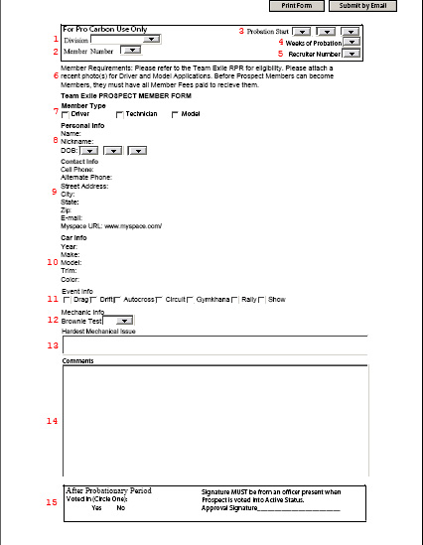

Prospect Member Form Explanation

1. Division – What division the member is applying for.
2. Member Number – A number that they choose 00-99 that has not been chosen by another member of their division. Member numbers are on a first-come-first-serve basis and switching numbers can only happen once per year but is not recommended. The recruiter is in charge of verifying that the number is not already taken.
3. Probationary Start Period – This is the exact date that the member is voted into Prospect Member Status.
4. Weeks of Probation – Weeks of probation are the amount of weeks that a member must complete hazing and/or auditioning and pay all member fees. After the number of weeks, the member is eligible to become an active member via vote.
5. Recruiter Number – If applicable, the recruiter number will be added to this document to show who and how many recruits an active member has gotten.
6. Requirements – This is a reminder for all members to read the Team Exile RRP and a reminder of requirements to become an active member.
7. Member Type – What type of member ranking this person will be under.
8. Personal Information – First and Last name with Middle Initial or Middle name. The Nickname will be that person’s “handle” on the team. Month, Day, and Year of Birth.
9. Contact Information – Effective 2010, all members will be required to have an email address. Myspace.com membership is highly recommended and being added to the team’s group and your divisional group is highly recommended.
10. Vehicle Information – Year (eg. 1995), Car Make (eg. Honda), Model (eg. Civic), Trim (eg. Si Hatchback), Color (eg. Red).
11. Event Information – The Prospect Member must acknowledge what types of events they plan to participate in.
12. Brownie Test – For Technicians, each member must bake a batch of brownies for their Divisional Pro Carbon to determine if they can follow basic instructions. The ingredients must be purchased by the Prospect Technician and must be mixed and baked by the Prospect Technician. If the brownies suck, then the Prospect is automatically disqualified.
13. Hardest Mechanical Issue – This will depict the hardest mechanical issue that the Prospect Technician has Diagnosed and Repaired or Performed such as an engine swap, rebuild, or turbo install.
14. Comments can be used to describe background and vehicle modifications categorized in: Engine, Suspension, Wheels and Brakes, Exterior, Interior, and ICE.
15. After Probationary Period – A Divisional Carbon Kevlar or Pro Carbon must sign off on a member that has been voted on.

Prospect Sponsor Form Example
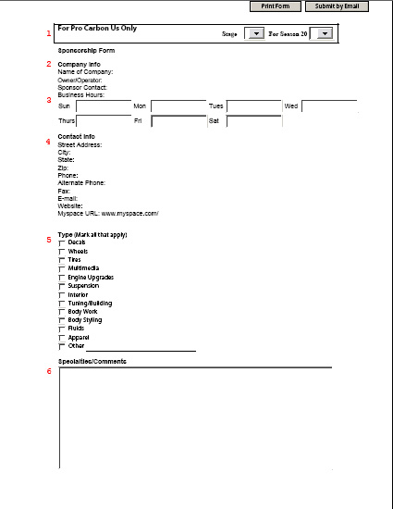

Prospect Sponsor Form Explanation

1. Stage and Season – What Stage of Sponsoring and what season that form is for.
2. Name of the business and owner/operator along with the name of the representative that the members will be contacting for parts.
3. Business hours (eg. 9:00am-6:00pm)
4. Contact Information of the company with the primary number being the number of their representative.
5. All the types of products the business will supply.
6. Comments about the company.

